Courageous Leaders – Elevating Voices from the Margins
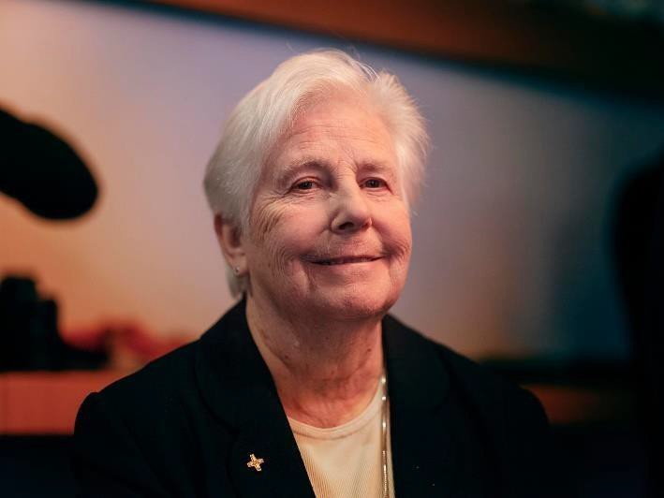
Thank you for the opportunity to participate in this afternoon’s round table. My name is Sr. Pat Murray ibvm. I come from Ireland and currently I am the Executive Secretary/Executive Director of the International Union of Superiors General. This is the organization whose members are the leaders of nearly 2,000 congregations of Catholic Catholic Sisters spread across the
Sr. Patricia Murray, ibvm

world. It is estimated that there are more than 600,000 Catholic Sisters worldwide but no one really knows how many we number. We sisters, are living and working close to the people, particularly with those on the margins of society:
- the poor and hungry,
- the marginalized and oppressed,
- migrants and refugees,
- victims of human trafficking and every kind of exploitation.

Sisters are involved in health care and health programs; we work in both formal and informal education offering basic literacy programs in remote areas and refugee camps while leading schools and universities. We are engaged in development work with local communities, with women’s and youth groups.

We are advocating for structural change at local, national and international levels, with and on behalf of those who are among the most forgotten and neglected.

Courageous leaders have a clear purpose and a vision and as sisters our vision and purpose comes from our faith commitment and our vowed life of service for the good of others. Our Gospel vision means that we want to create the conditions so that every person can live a full and dignified life. We are with the people, we don’t exclude anyone and we don’t leave when violence, conflict and civil unrest breakout. As we meet today there are hundreds of sisters in Ukraine and in many other countries where conflict is occurring, meeting the practical and spiritual needs of the people as best they can, often putting their
own lives in danger? We have all probably seen the photo of Sr. Ann Rose Nu Tawng kneeling in front of the soldiers in Miyitkyina, Myanmar with her arms outstretched begging a group of soldiers to spare the life of the young people, “the children” she called them and asking them to shoot and kill her instead. Since then, she has been detained several times by security forces. Recently sisters in Sri Lanka shielded the people protesting about power cuts and the lack of fuel and medicines. Last year in Rome I met Sr. Gloria Cecilia Narvaez from Colombia after her release from almost five year’s captivity in Chad. She was serving as a nurse at a large health centre and took the place of a younger sister when her captors came to the compound.

These are dramatic examples of courageous leadership but courageous leadership mostly happens in quiet and hidden ways. It requires humility, steadfastness, openness to the new, willingness to risk and fail and begin again. It requires trust and authenticity. I think of the many thousands of sisters who exercising that kind of courageous leadership in many different sectors.
These include
- Sisters developing programmes to improve maternal and children’s
health especially in remote areas through basic health education.
- Sisters tackling human trafficking through 60 worldwide networks - in 2021 alone their work in prevention reached 140,000 people and 16,000 were rescued; they helped to secure 1126 prosecutions and they established 32,000 local partnerships
- Catholic sisters and their collaborators are part of the Laudato Si Action Platform where we join with millions of others, to move forward with a coordinated response to focus on the 7 LS Goals:
  - Cry of the earth
  - Cry of the poor
  - Ecological economics
  - Sustainable lifestyles
  - Ecological Spirituality
  - Ecological education
  - Community Resilience and Empowerment

These past years we have learnt that by creating worldwide networks across religious congregations and by developing partnerships at every level – such as this partnership with the Global Solidarity Fund – that together we can bring about change in those significant issues that are affecting our human life. Pope Francis reminds us in LS 79 that “in this universe shaped by open and intercommunicating systems that we can discern countless forms of relationships and participation.” That is why we are here – to seek to promote imaginative partnerships for change.

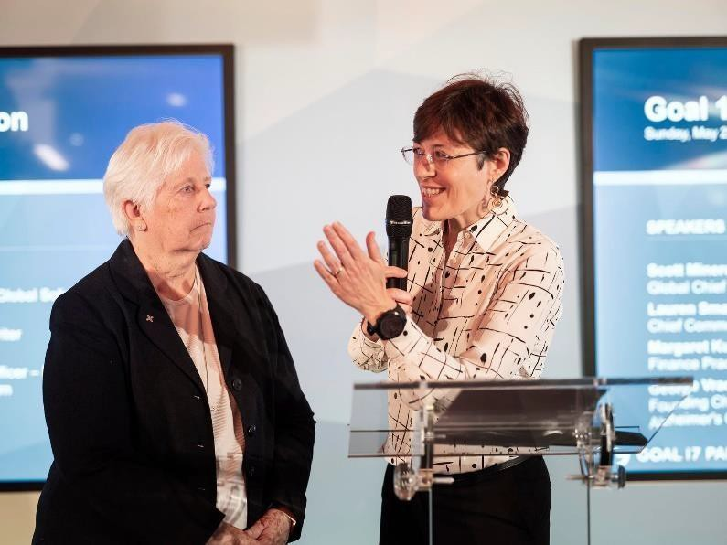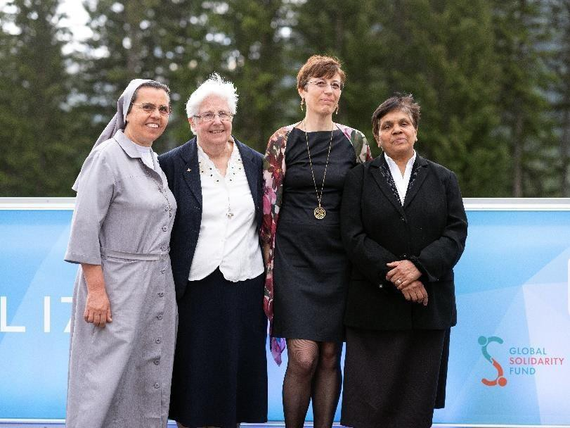

More photo here

