Advancing Courageous Leadership: Davos May 22-24, 2022

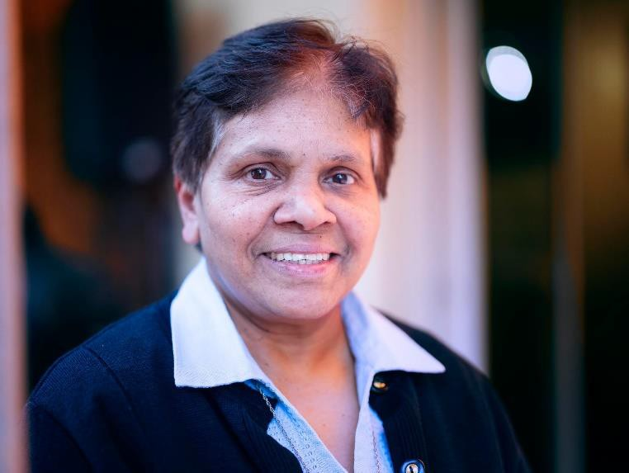
We are living through times when leadership in the Church and in religious congregations is undergoing tremendous changes, is questioned, challenged and even attacked from various quarters. However, that cannot undermine the fact that the Church, and women religious in particular, have given and continues to give courageous leadership on several fronts: in the areas of education, health, social services,

Sr. Mary John Kudiyiruppil, SSpS

women empowerment, dignity and rights of indigenous peoples, and people living in the lowest strata of society or in extreme poverty.

Courageous leadership is risk taking, starts at the grassroots. Courageous leadership is not always the most visible or recognizable style of leadership.
Today we realize that big changes cannot happen only by addressing urban needs. Religious sisters often have first-hand knowledge of small local communities; they are often closer to the struggles, needs and strengths of small hidden away communities.

One such encouraging story is from Pune - India where the sisters run a Centre called Streevani meaning the voice of women. Women domestic works have been one of the most disadvantaged groups of workers in India because they are considered unskilled. They belong to the unorganized sector of labor. It was the initiative of Sr. Jeane to gather these women, to organize them to fight for their rights. It started as a small movement among some timid women culminating in the formation of National Domestic Workers’ Movement. The movement met with many oppositions from the rich and abusive employers but religious sisters who stood by the woe and gave them a voice, education into their rights and dignity.

Today they are registered under the Indian labor law. These women come under the lowest strata of society; they need somebody to stand with them.

The movement quickly spread across 16 states of India, engaging nearly 200,000 domestic workers in major cities, towns and villages. It has made a lot of difference to the working condition of women domestic workers in terms of restoring the dignity and rights that they are workers like anybody else. The movement helped to address the issues that women were facing in their workplaces.
  - The stigmatization of domestic workers and their work.
  - Total absence of rights and legal protection (sister lawyers like Sr. Julie George started to take their grievances in court of law),
  - Absence of training, support and bargaining power (Streevani organized regular and systematic training programmes, conscientization programmes for them)
  - The stigmatization of domestic workers and their work

Why it is courageous because here we are defending the defenseless, the poor, women. It is courageous because you run the risk of displeasing the rich employers whom you need as well. Because you are also upsetting the status quo and invite the fury of many. The movement was almost entirely the initiative of religious sisters.

Courageous leadership is selfless and faith based.

Courageous leadership is also faith based. The assurance that God is with us, and the conviction that we are doing the right thing or making the right decision, and that the steps we take are making a difference for the better in the lives of people, these are the driving or motivating forces here.

Since sisters mostly work in health and educational fields, two vital areas of development, in a time of crisis or conflict, they normally do not run away leaving the people. Religious sisters in South Sudan are constantly in danger of being attacked. To give an example, in 2016, in Yei- South Sudan, Sr. Veronica Raskova - one of our doctor sisters from Slovakia had to give up her life in the act of defending and promoting life. She drove a woman in labour to the hospital at night, and on her return, she was shot by the rebels. She died two days later. Similarly in Ukraine, a sister in Kiev working in Radio Maria, lived for weeks in the studio, animating the people, praying with them and reflecting on the word of God with them. These are not sporadic incidents, but is pattern. The impact it has on the people that they feel secure, trustworthy.

Others who had to flee, of necessity, moved to the border of Poland and responded to the needs of the Ukrainian refugees who were flocking there. A similar situation occurred also in Yei, South Sudan. When we could no longer operate there because of the open rebellion and bombs, Sisters moved to neighbouring Uganda to the refugee camp to cater to Sudanese refugees in Uganda in collaboration with the Jesuit refugee services. This is courageous leadership.

The creation of a Ukrainian fund not only to address immediate needs of the people, but also to rebuild post war Ukraine is the joint effort of many congregations and communities within congregations. Several of our communities have opened their doors to welcome refugees from Ukraine. My community in Rome has accommodated seven Ukrainian women.

There is a centre for meditation in India in Igatpuri called the Vipasana Meditation Centre. Initially the people who frequented the centre were mostly priests and sisters. Today most people who go there for the 10 day programme of meditation, reflection, soothing music and body discipline are the CEOs, and other top officials of big and not so big companies. It is another example which throws light on the fact that faith based practices may in fact help administrative effectiveness.

If we examine the last two years, and our present times, we can see that two phenomena that impacted human life globally are the Pandemic and the war in Ukraine.

I was in India last year when the Delta Variant was raging through the country. In the face of this emergency all Catholic Hospitals (mostly run by sisters) suspended all their regular activities, converting large portions of the hospitals into Covid wards. Simultaneously the hospital launched extensive vaccination programmes - at times administering 2000 vaccinations a single day in Holy Spirit Hospital Mumbai. It was also a great experience of networking with organizations, pharmaceutical companies and NGOs pooling our resources together. The administrator of the Holy Spirit Hospital in Mumbai Sr. Sneha Joseph herself volunteered to give samples for research in the plasma therapy which was popular then.

Another important aspect of courageous leadership is not to lose hope but to repurpose the available material, to be creative and practical about what is around, and to start something small but purposeful.

I believe that the female congregations in particular have a natural propensity to see what is needed in a place, an instinctive sense of what could be done and how something could be done. They are gifted with great practical sense and ability to respond promptly and creatively to the situations which present themselves for attention and action. Missionaries have shown capacity to respond to emergencies, to rise up to the occasion, to have the presence of mind, to apply common sense and caution, to dialogue with the people and to take them on board in their projects. These, I consider, are important landmarks of courageous leadership.

Courageous leadership is participative and inclusive. We derive strength and courage when we are supported, when we take other people’s ideas and help. It is important to stay together, to ask for advice and guidance, to listen to each other and to put to best use the capacities and capabilities that are there among the members and among the beneficiaries. It calls on the expertise and gifts of others. Nobody is so low or poor that they have nothing to offer, and nobody is so rich or independent that they have nothing to learn from others.

To cite another example, in Pune, India, we have a Centre called Streevvani or Voice of Women. It runs several programmes like Women Domestic Workers Movement, Micro credit Project whereby women can invest their small savings or take loans to start some small business and be more self-reliant. And there are Sister lawyers who fight the cause of women domestic servants who are often victims of abuse of various types and women who endure domestic violence. It is a fulltime network of religious women, lay men and women social workers, lawyers, NGOs, and All India Domestic Workers Movement. These women who are often labelled as unskilled and therefore inferior, would have otherwise no voice at all, but now they feel secure, organized and they find a platform to redress their grievance.

They go to places where others would rather not. Since religious congregations are spread even to the remotest corners of the world, they are closer to people who hold potential for change and transformation in small, hidden- away local communities. Women religious in particular have access to the strata of society that are often denied to the men. For example, the whole ambit of women’s health and hygiene, maternity care and matters related to mother and child welfare are important areas when we talk about development. Our experience is that we are trusted by people even in these highly private spheres of families.

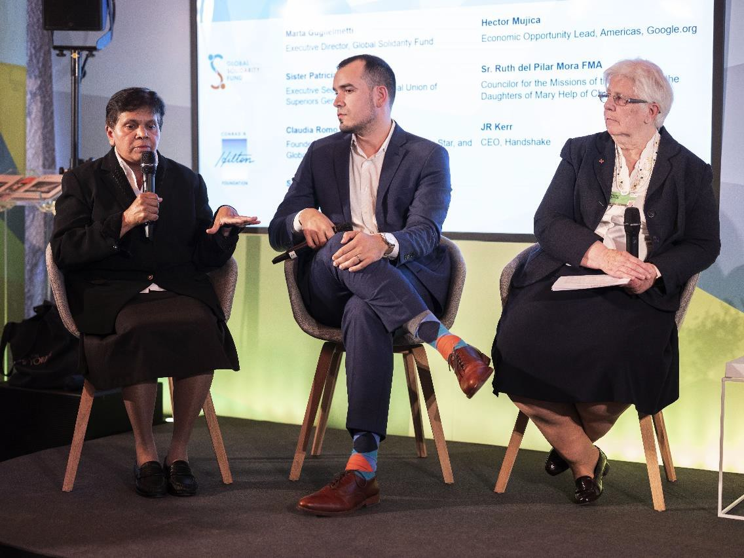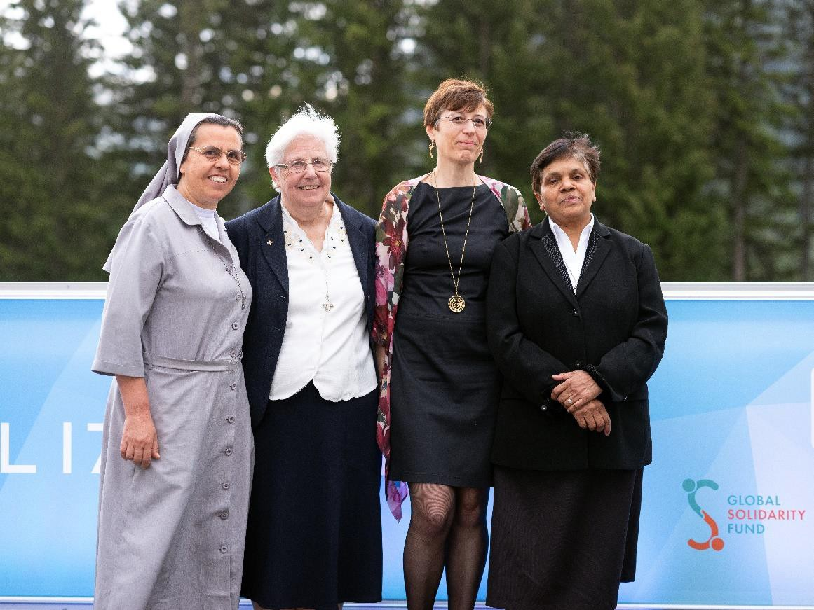

More photo here

